**Machine learning**

**GBM: Gradient Boosting Model**

**It’s a part of decision tree model .Ensemble modelling**

**Training a GBM Model in R**

In order to train a gbm model in R, you will first have to install and call the gbm library. The gbm function requires you to specify certain arguments. You will begin by specifying the *formula*. This will include your response and predictor variables. Next, you will specify the *distribution* of your response variable. If nothing is specified, then gbm will try to guess. Some commonly used distributions include- “bernoulli” (logistic regression for 0–1 outcome), “gaussian” (squared errors), “tdist”(t-distribution loss), and “poisson” (count outcomes). Finally, we will specify the *data* and the *n.trees* argument (after all gbm is an ensemble of trees!) By default, the gbm model will assume 100 trees, which can provide is a good estimate of our gbm’s performance.

**Packages:**

Various forms of gradient boosting are implemented in package gbm (tree-based functional gradient descent boosting).

Package xgboost implements tree-based boosting using efficient trees as base learners for several and also user-defined objective functions.

The Hinge-loss is optimized by the boosting implementation in package bst.

Package GAMBoost can be used to fit generalized additive models by a boosting algorithm.

An extensible boosting framework for generalized linear, additive and nonparametric models is available in package mboost.

Likelihood-based boosting for Cox models is implemented in CoxBoost and for mixed models in GMMBoost.

GAMLSS models can be fitted using boosting by gamboostLSS. An implementation of various learning algorithms based on Gradient Descent for dealing with regression tasks is available in package gradDescent.

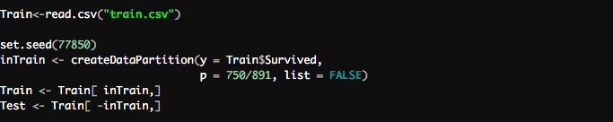

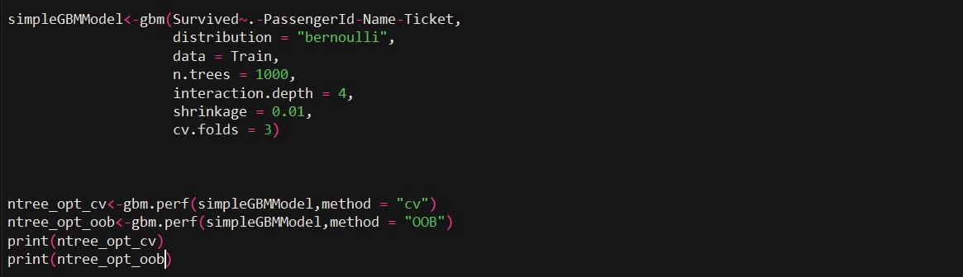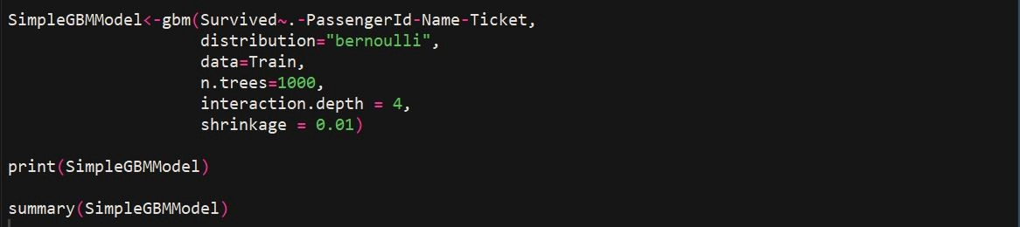

CONFUSION MATRIX



